**Assignment No-1**

**Project Name-Elevations Credit Union**

**IST 647**

**Group Members-**

Swapnil Nikam (006706772)

Digvijay Singh (005791834)

Mohammed Saad (006712128)

Shubhankar Jathar (006704614)

**Processes & entity**

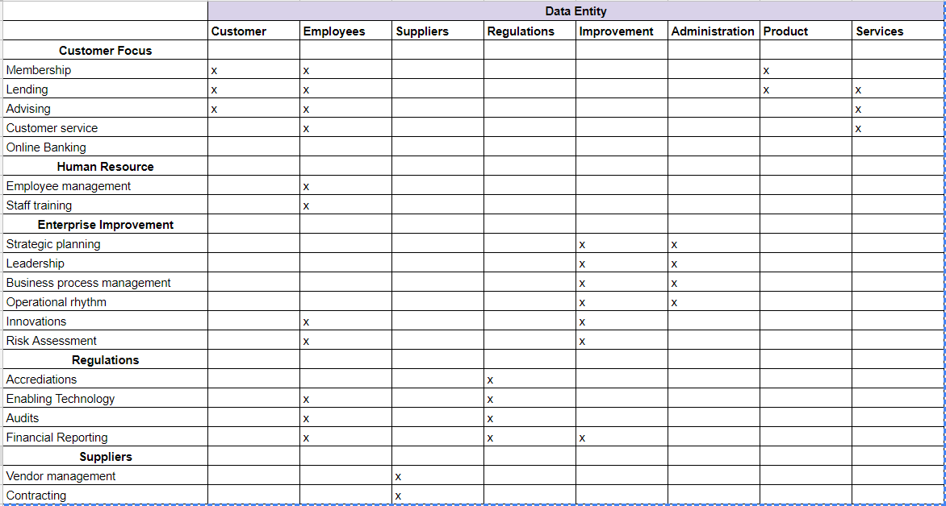

**Business Process or Use Case/Data Entity**

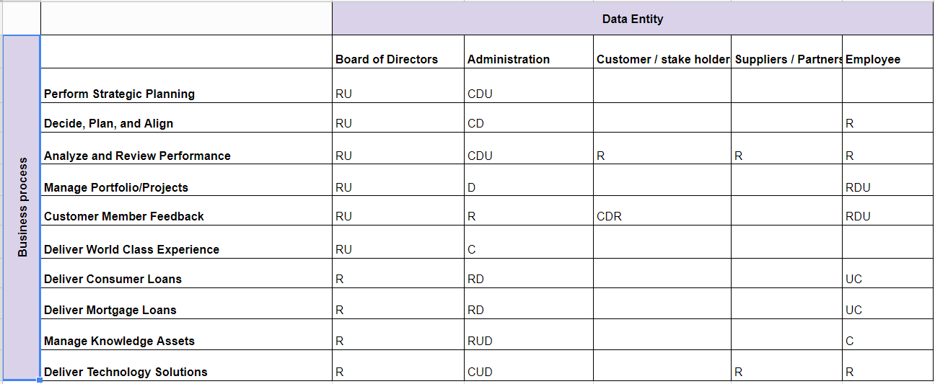

**Application Systems/Data Entity**

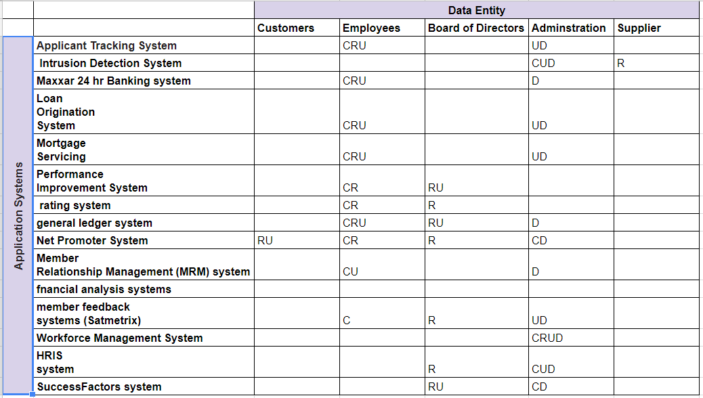

**Business Entity/Data Entity**

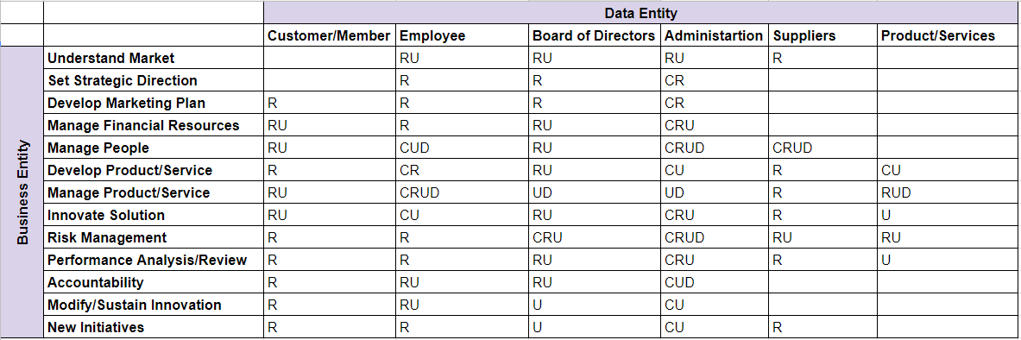

**Report/Data Entity**

